**CSE - 5334 - 001 : Data Mining**

**Assignment 1 - Exploratory Data Analysis**

**Instructor: Dr. Elizabeth D Diaz**

**Team 18: Urmi Manish Sheth – 1002064934**

**Harsh Navinbhai Shah – 1002057387**

**Sai Swetha Tadivaka – 1002112726**

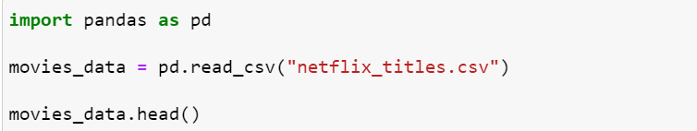

**Task 1A:**

Display all the details about the dataset.

**Task 1B:**

Display all the details about the dataset.

1. Check for null values within each column.
2. Fill the values for more than 100 missing columns with certain labels such as No Director, Country Unavailable, etc. Drop the rows for the rest of the missing columns.

**Task 1C:**

Display a two horizontal bar chart side by side for Top 10 countries with total number of movies and TV shows.

**Task 1D:**

Print the first row based on the longest duration time of a movie from each country column with its director, date_added, release_year, duration of the movie and its description.

**Task 1E:**

Display the title of the movie, its director, the date it was added to the platform and the date it was officially released where the official release date and the date it was added to the plafform has same year.

**Task 1F:**

Display Director, the release year and number of movies and TV Shows directed by that director within a year and sort the results from highest.

**Task 1G:**

Display the title of the movie/TV shows, the Director, the date it was added to netflix and the category it was listed in from the data which belongs to Documentary/Docuseries category.



**Task 1H:**

Display title, the date it was added to the plaform, type of category it was listed in and its description for Family Dramas.

Hint: Use Description to look for type of Drama.



**Task 1I:**

Plot the Distribution of TV shows based on their number of seasons. (horizontal bar chart)

1. Less than 3 seasons
2. 3 Seasons
3. 4 Seasons
4. 5 to less than 10 seasons.
5. 10 or more seasons.

**Task J:**

Display a side by side pie chart where it shows different rating a movie and a TV show belongs to.

Movie:

1. Uncut/Not rated
2. Restricted
3. Parentel guidance
4. General audience
5. Adults only

TV Show:

1. All Children
2. Older Children
3. Parentel Presence
4. General audience
5. Mature

**References:**

<https://pandas.pydata.org/docs/user_guide/index.html#user-guide>

[Pandas groupby() and count() with Examples - Spark By {Examples} (sparkbyexamples.com)](https://sparkbyexamples.com/pandas/pandas-groupby-count-examples/)

[Using pandas and Python to Explore Your Dataset – Real Python](https://realpython.com/pandas-python-explore-dataset/)